**Skysikkerhet 1: lab 4**

**Get HTTP server image: docker pull httpd**

**4. Check that you have Apache docker image in place: docker images**

**5. Launch instance of Apache Web server: docker run -d -p 8000:80 httpd**



**Note: The -d (detach) option is needed so that the container stays running**

**in background. The -p 8000:80 option is mapping port 80 of the container**

**to port 8000 in the host, making the webserver available in the network.**

**By default, container ports are not exposed to the host.**

**6. Open Firefox, type http://localhost:8000 and Enter**

Skriver localhost :8000 på firefox i ubuntu og får opp

**7. Let’s try to change the webpage content in the docker. (We need to**

**link a folder from the host into the container /usr/local/apache2/htdocs/**

**directory (we’ll see later that the Apache image is built from a Debian**

**Jessy, regardless of the linux flavor of your host). Then stop the container**

**and run it again.)**

**11. Launch docker container with a link to our html file: docker run -d -p**

**8000:80 -v ”$PWD”:/usr/local/apache2/htdocs/ httpd**

**1**

**12. We created an index.html file in the current directory in the host and**

**mapped this directory inside the htdocs directory of the container with**

**the -v switch. Now refresh the web browser.**

**LINKER FILEN**

**8. Check running docker containers: docker ps and find a name of our docker**

**- something like cranky Torvalds**

**9. Stop the container: docker stop cranky Torvalds**

**10. Create own small html page and store it in the file in current directory:**

**e c h o ”<html><body>My Webpage</body></html>”>i n d e x . html ”**



**Åpner med firefox**

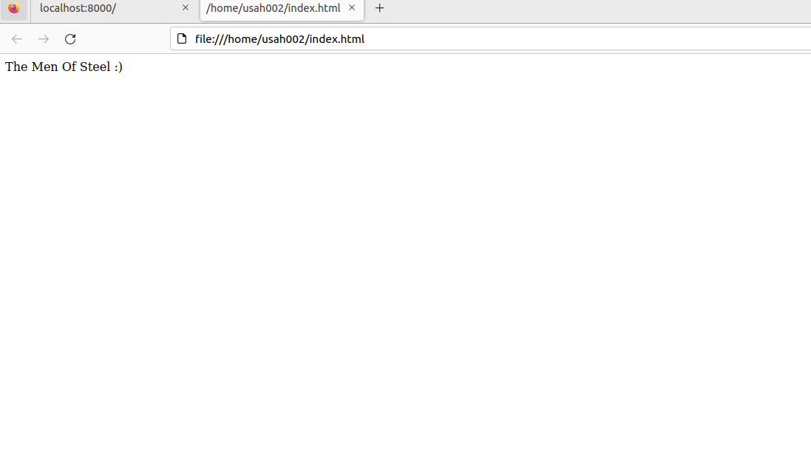

**11. Launch docker container with a link to our html file: docker run -d -p**

**8000:80 -v ”$PWD”:/usr/local/apache2/htdocs/ httpd**



**1**

**12. We created an index.html file in the current directory in the host and**

**mapped this directory inside the htdocs directory of the container with**

**the -v switch. Now refresh the web browser.)**

**13. Let’s do some denial of service (DoS) attack and see if the websiter can**

**handle it. Run top in one of the terminals.**

**For å kjøre en dos** attack åpne terminal skriv : top kommandoen deretter åpner du en ny terminal skriv **ab -n 100000 -c 100 localhost:8000/.** også vil man se at load balance øker for når du utfører benchmarken min load balance gikk fra 0.75 til 11.03 men fortsatte å øke fordi vi sender mange requests til localhost webserveren vårt som kan medføre overlapping og utestenging av bruker fra nettverket hvis man fortsetter

**14. Performance benchmark in another terminal: ab -n 100000 -c 100 localhost:8000/.**

**It will send 100000 requests in overall with 100 concurrency towards web**

**server in our running docker container.**

**:**